P303 Arduino OBD-II Data Logger Project Notebook
Initial Research:
Forums
Store / Product Purchased
Download
GitHub Instructions
https://freematics.com/pages/products/arduino-telematics-kit-1/

2/18/24 @ 5 PM - Ordered the Freematics OBD-II Kit, which ships from Australia. No delivery estimate was available at the time, but forum discussions suggested that orders typically ship within one or two days and arrive within approximately two weeks.

Important note: The kit is designed for vehicles manufactured in 1996 or later that support OBD-II.

02/23/24 @ 8 PM - According to USPS tracking, the OBD-II Kit has reached Chicago and is arriving sooner than expected.

02/27/24 @ 5 PM - OBD2 Kit has arrived.

Note: The initial objective was to test the kit as a standalone system before attempting to integrate it with the course-provided board.

PART 2: Initial Testing / Planning

Spring Break - Initial standalone testing began with the goal of verifying the kit's basic functionality.

Pin Wiring Set Up:
OBD-II Adapter: Red = VCC, Black = GND, White = TX, and Green = RX.
LCD Display: VCC, GND, SDA, SCL

Important note: The Arduino receives power through the vehicle's 12 V OBD-II port. The adapter converts this input to 5 V for the connected device.
Note: The DS18B20 temperature sensor provided in Lab 5 was tested successfully.
Note: The project can read engine and transmission diagnostic trouble codes.

Data available through the OBD-II adapter (based on the Freematics documentation):
Units vary by parameter and vehicle configuration.
Engine RPM (rpm)
Calculated engine load (%)
Engine coolant temperature (°C)
Absolute Engine load (%)
Ignition timing advance (°)
Engine oil temperature (°C)
Engine torque percentage (%)
Engine reference torque (Nm)
Intake temperature (°C)
Intake manifold absolute pressure (kPa)
MAF flow pressure (grams/s)
Barometric pressure (kPa)
Vehicle speed (km/h)
Engine running time (second)
Vehicle running distance (km)
Throttle position (%)
Ambient temperature (°C)
Vehicle control module voltage (V)
Hybrid battery pack remaining life (%)

libraries - Arduino libraries required by the OBD-II adapter and kit
- samples - Simple sketches for initial testing
- nanologger - OBD-II data logger for an Arduino Nano with a 128 x 64 monochrome OLED display; selected as the foundation for this project
- megalogger - OBD-II and GPS data logger for an Arduino Mega with a 320 x 240 TFT LCD
- megaloggerHD - OBD-II and GPS data logger for an Arduino Mega with a 480 x 320 TFT LCD
- tester - Test sketch for OBD-II communication and supported parameters
- utilities - Supporting utility source code

3/28/24 - Communication Testing
Upload the program to the Arduino Pro Mini, connect the Arduino to the laptop and the OBD-II adapter to the running vehicle, then open the Serial Monitor to verify communication between the vehicle and the Arduino.

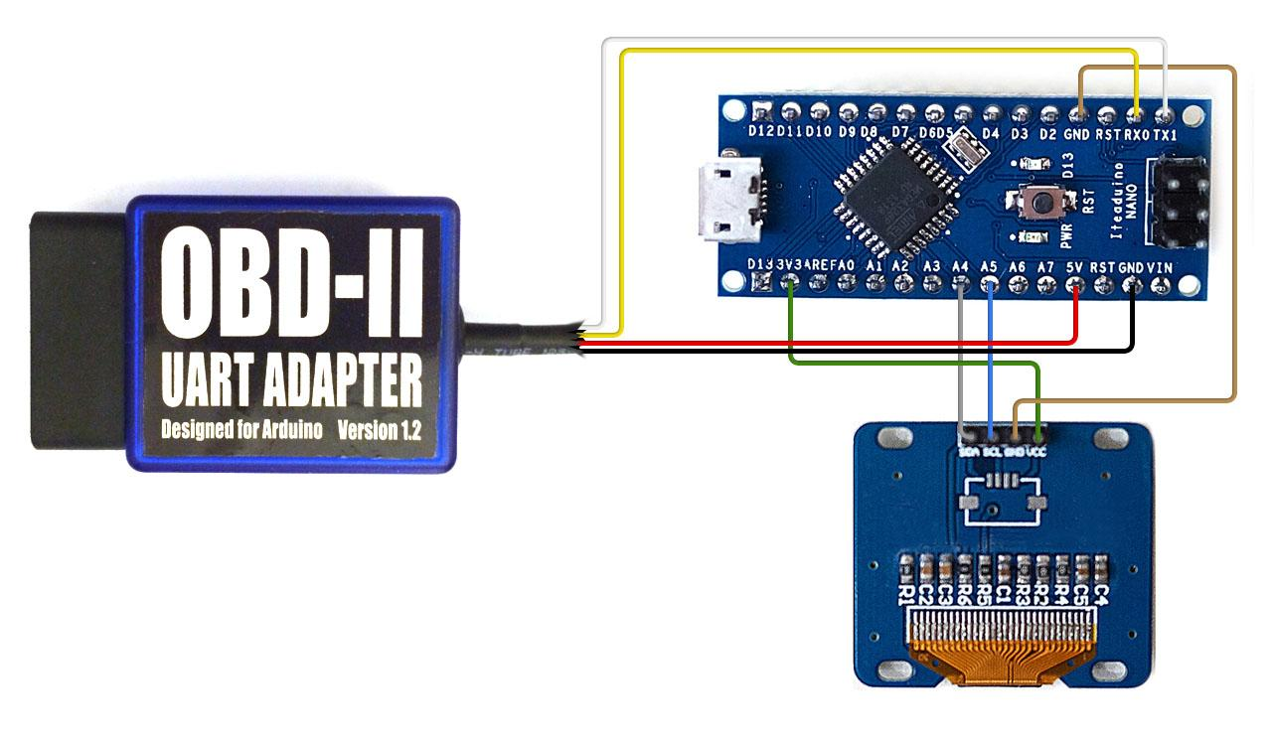

4/2/24 - Data logging was still not working. The next step was to remove the three pins from the course-provided Nano and solder the six ICSP pins onto the replacement board. The nanologger configuration requires the SD card module to connect through the ICSP interface.

Nanotimer - Measures vehicle acceleration from 0-60, 0-80, and 0-100.
Nanologger - Displays real-time vehicle data and records it to an SD card.

April 4, 2024 @ 9:48 AM - Initial testing confirmed that the wiring was correct: the OBD-II adapter received power from the vehicle and displayed live data. However, the SD card logging function was still not working, so I ordered a 5 V-compatible SD card module to eliminate a possible voltage-compatibility issue.
Next troubleshooting step: verify the RX and TX connections.
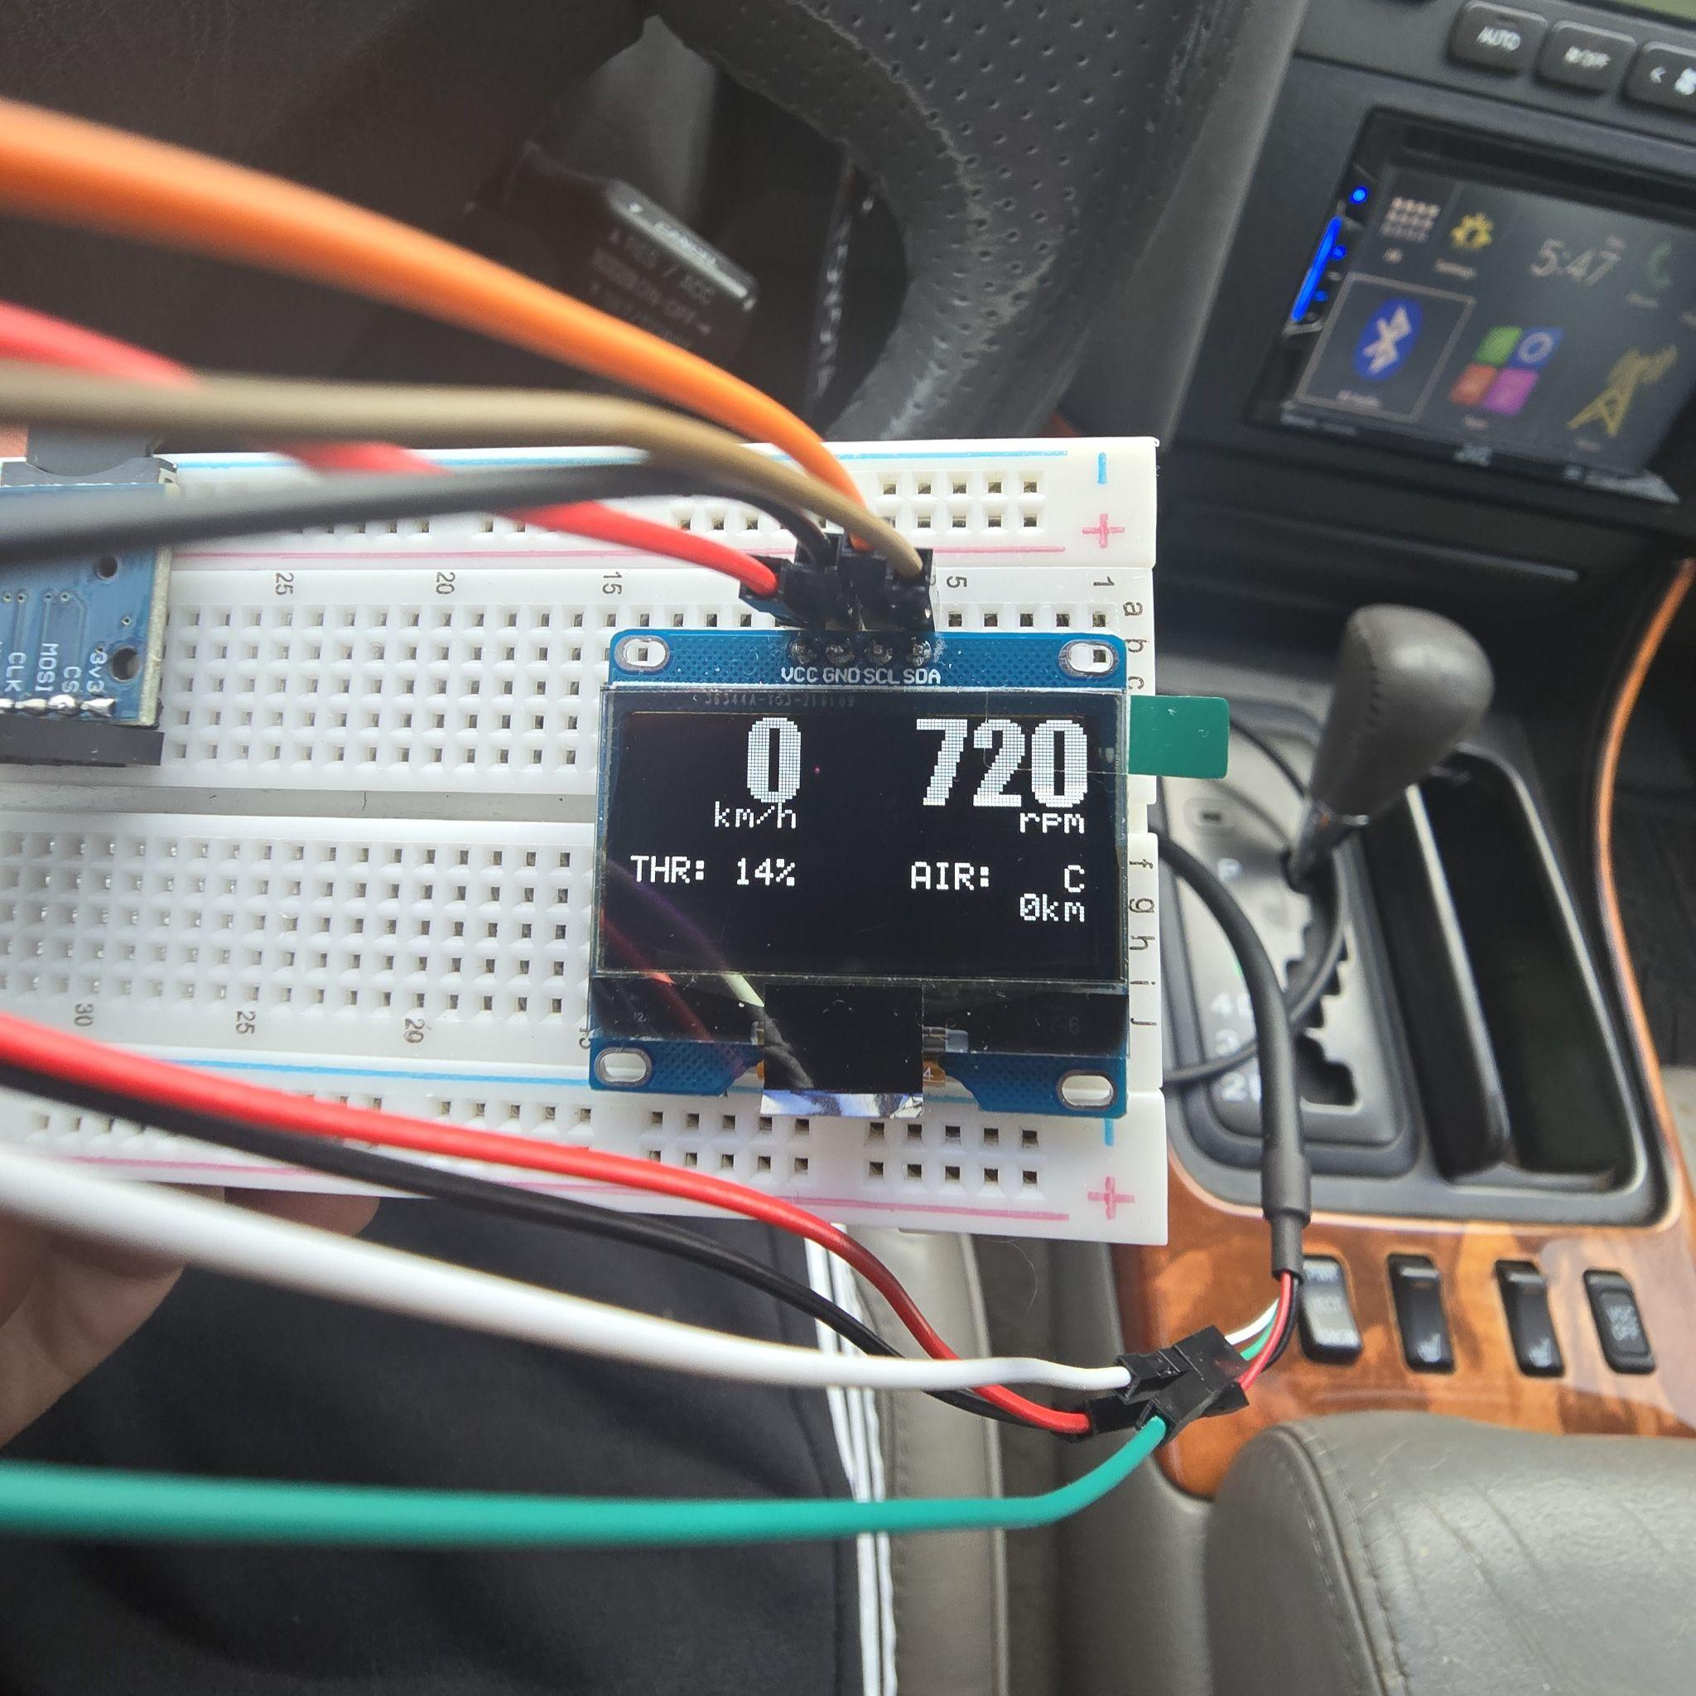
- Communication testing was unsuccessful with three Honda vehicles (2008 Accord, 2007 Civic, and 2008 Pilot). Successful tests were completed with Toyota vehicles (2010 RAV4 and 2008 Camry), Lexus vehicles (1999 GS 300 and 2010 RX 300), a 2006 Chevrolet Impala, and a 2013 Subaru Outback. The Chevrolet produced the most consistent initial results.
- Vehicle speed was reported in km/h even when the vehicle used imperial units. I added a conversion for the on-screen mph display, but the recorded CSV values continued to use km/h.
- Access to several vehicles made it possible to compare compatibility and data output across different manufacturers and model years.

Part 3: Code Optimization and Extended Testing
I paused notebook updates during the extended testing phase while I analyzed the Freematics reference code. Although the LCD displayed live data, the SD card logging functionality was initially inactive. In config.h, I discovered that #define ENABLE_DATA_LOG was set to 0. After enabling it, the compiled sketch exceeded the Arduino's available program storage by approximately 500 bytes. Because display strings consume program memory, I shortened several LCD messages and removed nonessential display functionality while preserving the system's core real-time monitoring and logging features.

Examples of shortened display messages (default -> revised):
- (“No Log”) → (“F1”);
- (“No Fat SD”) → (“F2”);
- (“Bad SD”) → (“F3”);
- (“Reconnecting”); → (“...”);

Using compact numbered failure codes reduced the message storage requirement from approximately 50 bytes to 6 bytes, in addition to the savings from other shortened display strings.

Removing the following SD card type-detection and display block saved approximately 30 bytes:

if (card.init(SPI_FULL_SPEED, SD_CS_PIN)) {
const char* type;

lcd.print("SD");
switch(card.type()) {
case SD_CARD_TYPE_SD1:
type = "1";
break;
case SD_CARD_TYPE_SD2:
type = "2";
break;
case SD_CARD_TYPE_SDHC:
type = "HC";
break;
default:
type = "x";
}

lcd.print(type);
lcd.write(' ');
if (!volume.init(card)) {
lcd.print("No FAT");
return false;
}

Removing the following distance-traveled display block from the main loop saved approximately 100 bytes:

char buf[10];
sprintf(buf, "%4ukm", (uint16_t)(distance / 1000));
lcd.setFontSize(FONT_SIZE_SMALL);
lcd.setCursor(92, 6);
lcd.print(buf);

I also removed code used to format data as binary values. These changes provided the remaining program-space savings needed for compilation. The source files contain comments identifying the sections that were added, changed, or removed.

After reducing the program size while preserving the LCD functionality, the first road test successfully created a file on the SD card. The recorded output was not yet structured as expected, although the values appeared to repeat in consistent four-line groups. I then examined datalogger.h, added section dividers and explanatory comments, and reviewed its five overloaded logData methods. Each method recorded a different group of parameters. I consolidated the required functionality into a single method focused on vehicle speed and engine RPM, producing a clearer CSV output for analysis.
Vehicle availability affected the testing schedule. A 2008 Honda Accord did not advance beyond the welcome screen, which initially led to additional troubleshooting of the hardware and code. Testing across other manufacturers showed that the same setup worked reliably with a Subaru, allowing development and validation to continue.

Compatibility varied by manufacturer and model. The tested Toyota and Lexus vehicles communicated reliably with the kit, as did the Subaru, while the tested 2004-2008 Honda vehicles did not. These observations are limited to the specific vehicles tested and do not establish compatibility for every model from those manufacturers.
The final optimization reduced the compiled program size from 30,820 bytes to 30,526 bytes, bringing it below the 30,720-byte limit and allowing the sketch to compile successfully. I also reorganized and documented the code and configured the logger to record vehicle speed and engine RPM. Potential future parameters include selected gear, distance traveled, and engine temperature, which could support broader comparisons among vehicles.
Part 4: Final Implementation

Final working wiring configuration:

OBD-II Adapter: The adapter wires are identified by color rather than printed labels. The white and green wires carry TX and RX signals. A successful live-data display confirms that the serial connections are oriented correctly.
- White Cable = Tx1 Pin
- Green Cable = RX0 Pin
- Red Cable = 5v Pin
- Black cable = GND Pin

LCD Screen: At startup, the display shows a welcome screen and reports the connection status of the OBD-II adapter, accelerometer, and SD card. After initialization, it displays live vehicle speed, engine RPM, the amount of data recorded, throttle position, and engine temperature. Parameter availability may vary by vehicle.
- VCC = 3v3 Pin
- GND = GND Pin
- SCL = A5 Pin
- SDA = A4 Pin

SD Card Module: Uses the ICSP interface. Orient the Arduino Nano as shown in the diagram before matching the following pins:
- CS = D10 Pin
- SCK = ICSP Pin 2 (SCK)
- MOSI = ICSP Pin 3 (MOSI)
- MISO = ICSP Pin 5 (MISO)
- VCC = ICSP Pin 6 (5 V)
- GND = ICSP Pin 4 (GND)
- Testing indicated that the logger could be disconnected safely before the data buffer reached 1,024 bytes; the source code provides additional context for the write process.
- I created the following wiring diagram as a reference for assembly and future troubleshooting.
Align the ICSP header and the triangle (or circular) orientation marker with the Arduino Nano as shown.
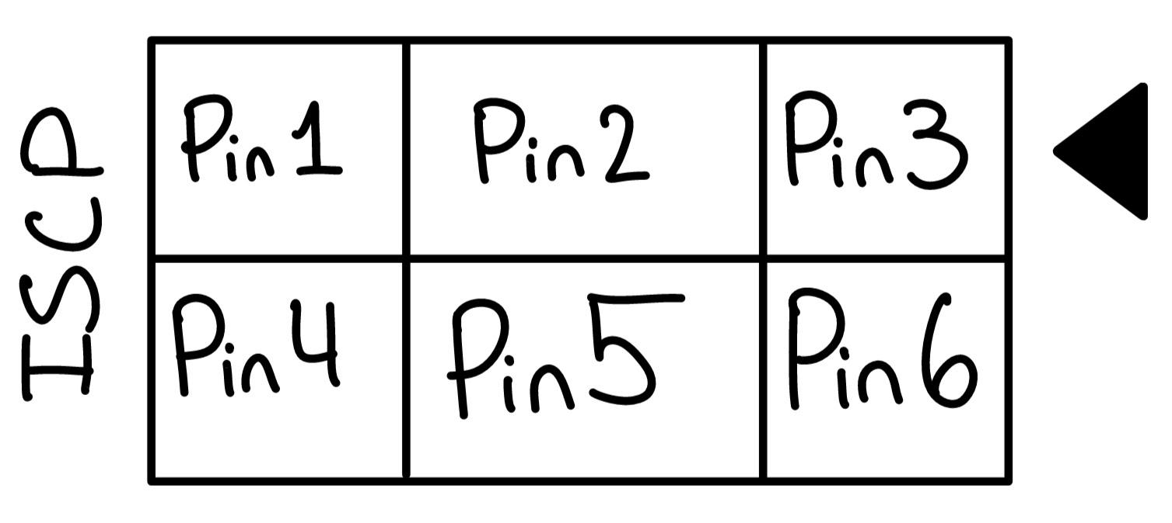
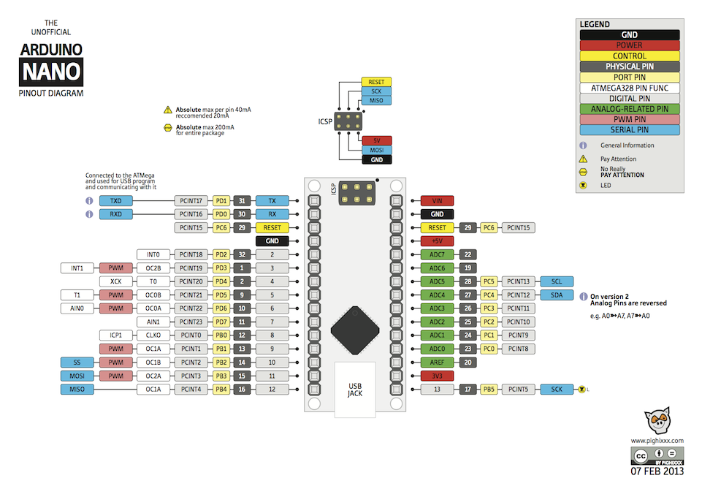

Photos of the Completed Data Logger
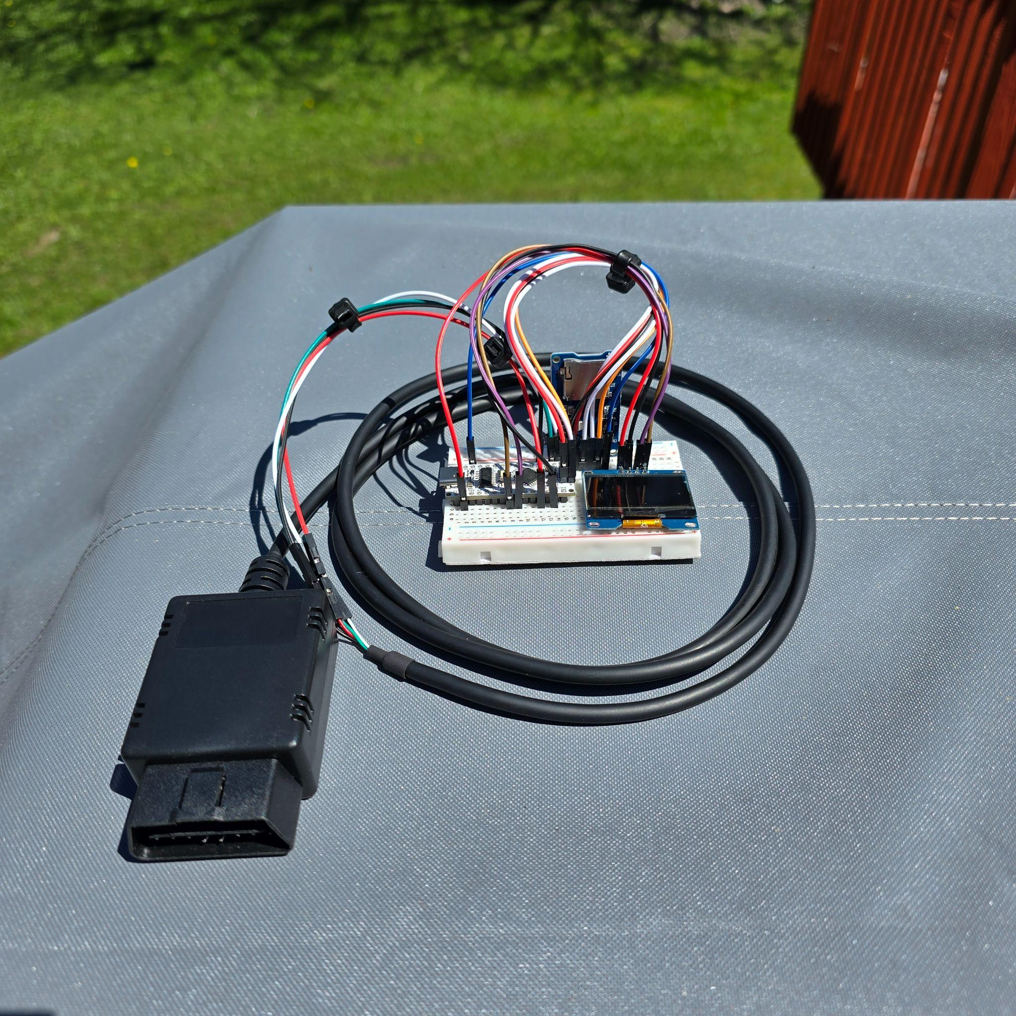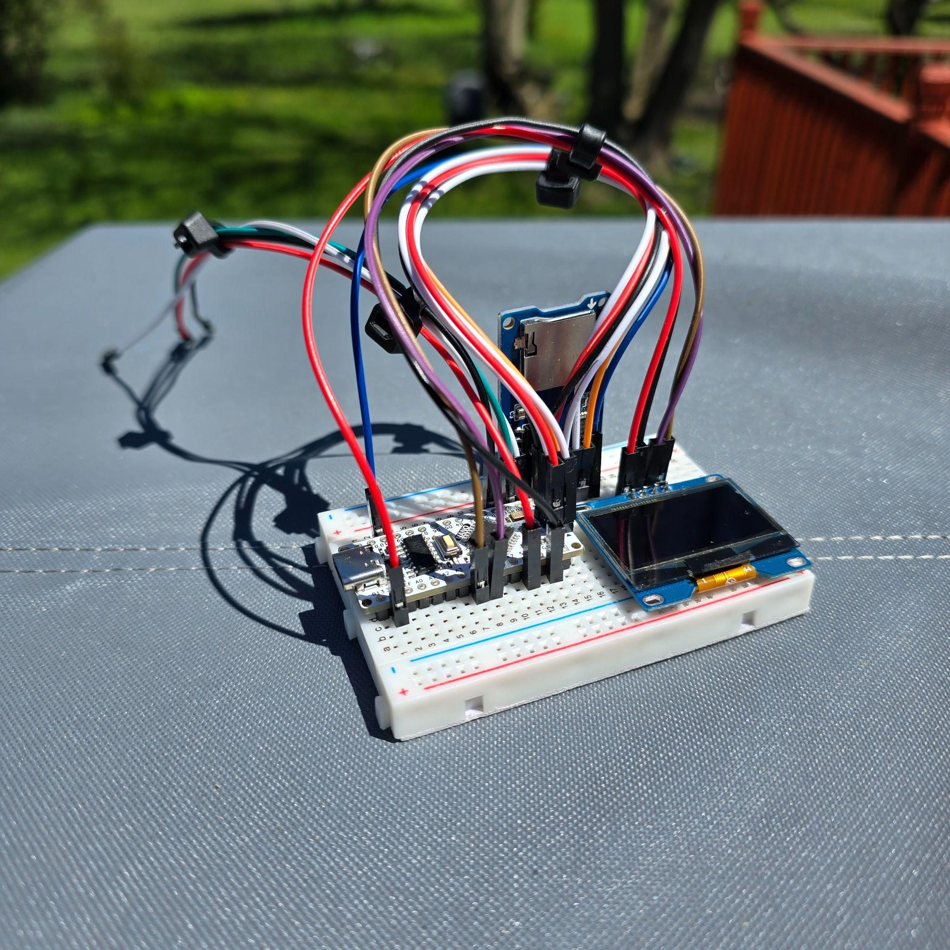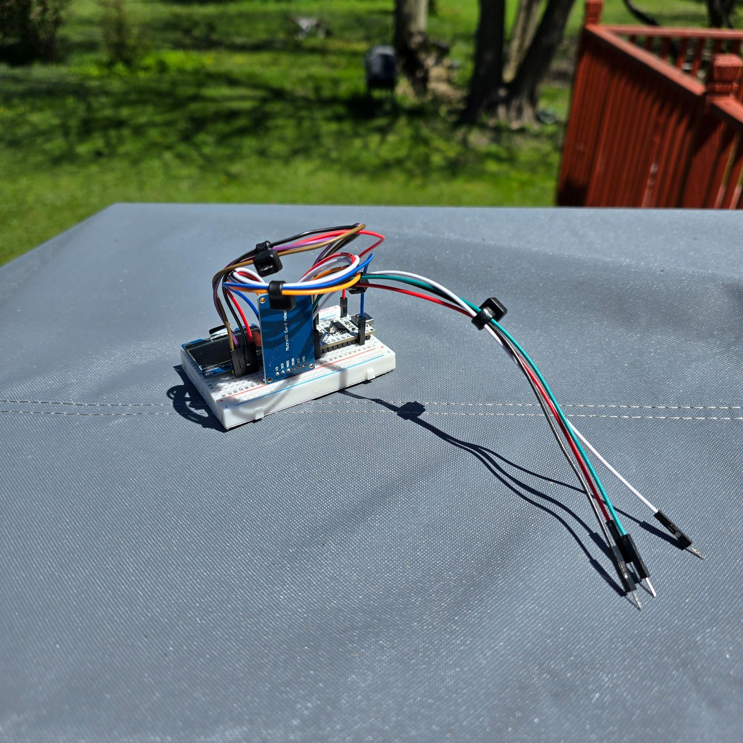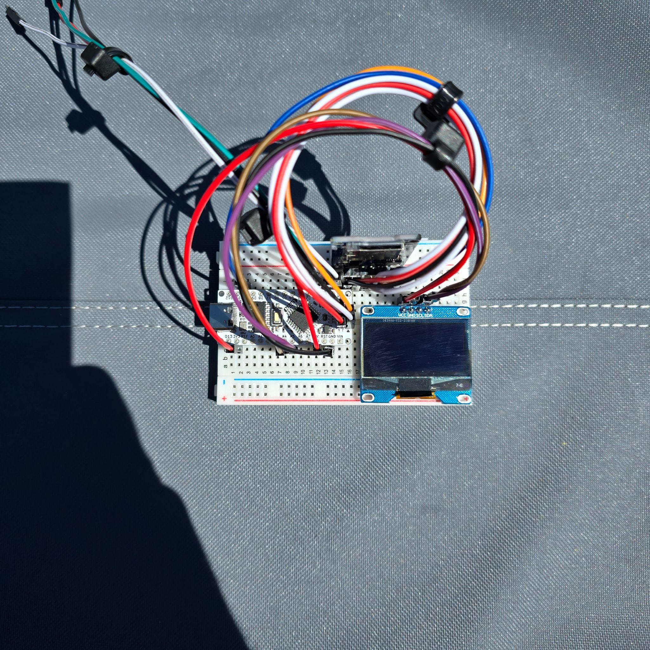

Graphs:
- The following annotated graphs summarize the recorded speed and engine RPM data. Full-resolution graph images are included with the project files.

Graph 1: Link.
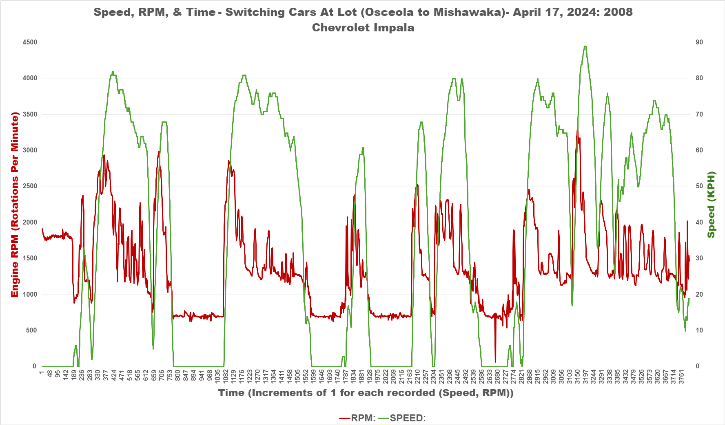
Graph 1: | Speed: | Rpm:
Max: | 89 kph (55 mph) | 3324
Average: | 37 kph (23 mph) | 1392

Graph 2: Link.
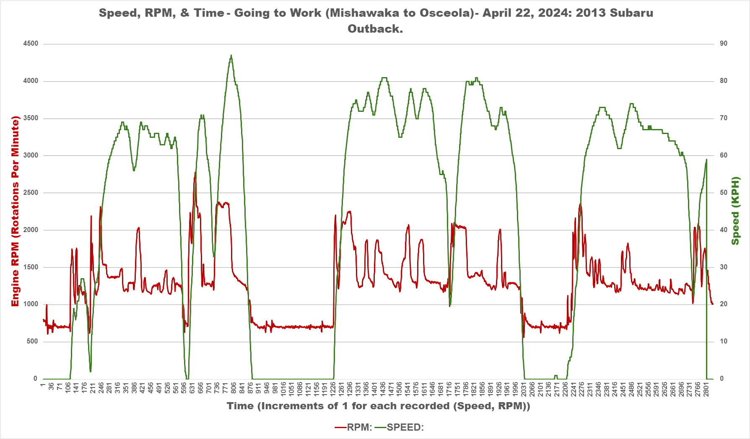

Graph 2: | Speed: | Rpm:
Max: | 87 kph (54 mph) | 2777
Average: | 44 kph (27 mph) | 1284

Graph 3: Link.
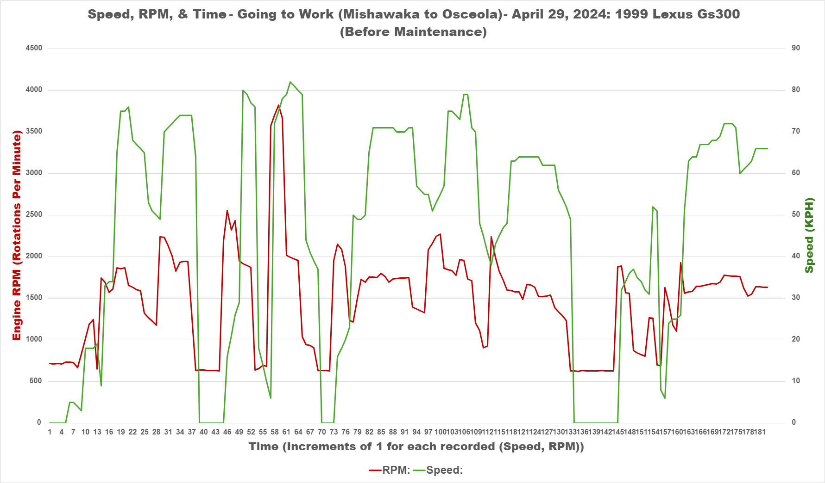

Graph 3: | Speed: | Rpm:
Max: | 82 kph (51 mph) | 3821
Average: | 45 kph (28 mph) | 1476

Graph 4: Link.
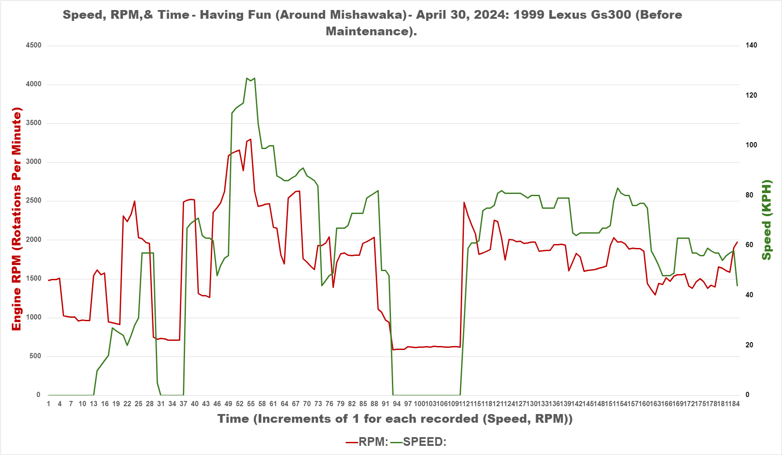

Graph 4: | Speed: | Rpm:
Max: | 127 kph (80 mph) | 3297
Average: | 53 kph (32 mph) | 1667

- Across the four data sets, average vehicle speed remained between approximately 20 and 32 mph.
- Average engine speed remained between approximately 1,200 and 1,700 RPM, while the maximum values were generally near 3,000 RPM. Graph 3 recorded the highest engine-speed peak at 3,821 RPM.

Graph 1 represents a trip beginning after work and continuing through several additional stops.
Graphs 2 and 3 have similar overall shapes because both data sets were recorded while traveling to work, although Graph 3 contains a shorter recording. Graph 2 contains substantially more samples than Graph 3. Differences in sampling totals and graph shape may reflect vehicle-specific response rates, traffic signals, traffic flow, speed, initial idle duration, trip length, and time of day. Because these conditions were not controlled, the graphs should be interpreted as observational comparisons rather than identical test runs.
The Lexus GS 300 produced the highest average engine RPM of the tested vehicles. This may indicate higher engine speed under similar driving conditions, but additional controlled testing would be required before drawing conclusions about fuel economy or maintenance needs. Its observed warm-idle speed was approximately 714 RPM, compared with approximately 803 RPM for the Subaru. The maximum speeds recorded by the logger matched the values observed during each test drive, and the expected relationship between speed and engine RPM was visible across the graphs. These comparisons support the logger's general accuracy while also identifying the need for repeatable routes and controlled driving conditions in future testing.

Important note: Secure all wiring and components before driving. Hard turns or acceleration can loosen the connections between the kit and the OBD-II adapter.

Conclusion and Future Work

The related Nanotimer program could support future before-and-after comparisons of vehicle acceleration following modifications.

The analysis phase also strengthened my ability to organize, visualize, and interpret recorded data in Microsoft Excel.

A future hardware improvement would be a compact 3D-printed enclosure for the Arduino, display, SD card module, and wiring. A small vent-mounted design could keep the unit accessible while reducing movement during a test drive.

This project combined two of my interests: automotive technology and computer science. I transformed partially functioning reference code into a working OBD-II data logger by troubleshooting serial communication and SD card output, reducing memory usage, restructuring the logging logic, and validating the results across multiple vehicles. Future improvements could include consistent mph output, protection against incomplete data writes, additional vehicle parameters, a compact enclosure, and more controlled comparative testing.

